The Wright Brothers
i-pod touch activity
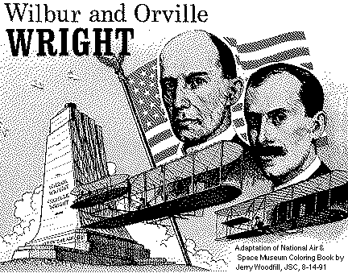
- Mapping Skills
  - Find the location (street address) where the Wright Brothers lived in Dayton, Ohio. __________________________________
  - Find the location (physical address) of the Wright Brothers Memorial in Kitty Hawk, North Carolina ________________________________
  - Drop a pin in both locations. Dayton, Ohio Kitty Hawk, N.C.
  - How many miles did the brothers have to travel from their home in Ohio to North Carolina? __________________________
  - How many travel hours would that take in a car today? __________________________
  - How long would it take if you walked that distance? __________________________

- Weather and Calculator
  - What is the temperature in Dayton, Ohio today? _________________
  - What is the temperature in Kitty Hawk, North Carolina today? ________________
  - What is the weekly average (mean) temperature for this week in Dayton? __________________
  - What is the weekly average (mean) temperature for this week in Kitty Hawk? __________________
  - What is the median temperature for this week in Dayton, Ohio? ____________
  - What is the median temperature for this week in Kitty Hawk, North Carolina? _________________
  - What is the range of the temperature in Dayton this week? _________________
  - What is the range of the temperature in Kitty Hawk this week? ______________
- Photos (Camera) and Safari
  - Find the following pictures and save them in Photos as a slideshow:
    - Picture of Wilbur as a child and then as a man
    - Picture of Orville as a child and then as a man
    - Picture of their home place in Dayton, Ohio
    - Picture of their bicycle shop
    - Picture of their sister Katherine
    - Picture of their first glider
    - Picture of their first flight
    - Picture of their cabins in Kitty Hawk
    - Picture of Wright Monument
    - Your choice of picture.

- Notes –
  - Write at least 10 facts you have learned about the Wright Brothers from this activity. Be sure to add you citations at the bottom of your notes page.
  - Email me your notes page altaallen@gaggle.net
  - Both of you will need to email your very own document.

- Use your computer and go to the following site to create a biography:
http://www.nasm.si.edu/wrightbrothers/classroomActivities/4-7_intro.cfm
You can search it from Google by searching the term:
Wright Brothers Biography: An Illustrated Biography
When finished:
- You will have to highlight the entire page and copy it.
- Then open up a Microsoft Word and paste it into the word document.
- Save your biography on your computer as:
1st Student Name and 2nd Student Name Wright Brothers Biography
- Drag it from the desktop and put it in the ALLEN folder.

